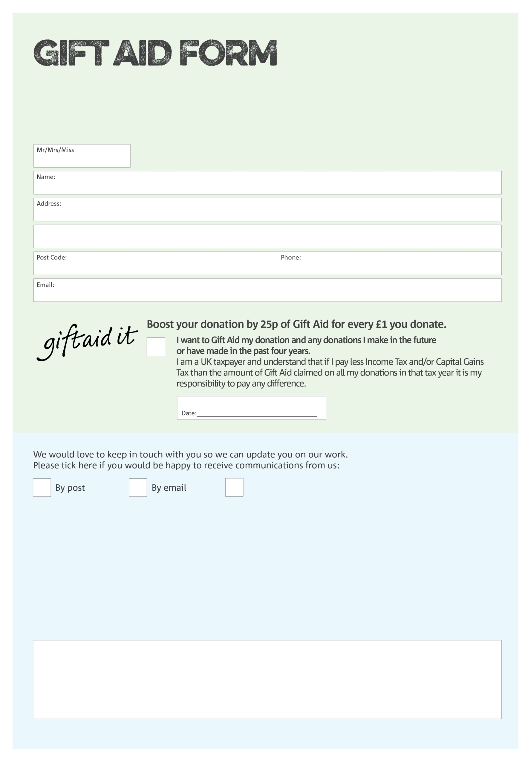

By filling in this form Falkirk Foodbank will receive an extra 25p for every £1 you give at no extra cost to you. Thank you!

We may need to get in touch with you to administer your Gift Aid donation. Please tick here to indicate how you would prefer to receive communications from us:

Please send to:

Falkirk Foodbank

Unit 1 Tamfourhill Industrial Estate   
Tamfourhill Avenue   
Falkirk  FK1 4RT

Charity Number SC043763. Registered in Scotland

Please let us know if you change address as we need up-to-date addresses each time we claim Gift Aid. Thank you.

Also, please let us know if you cease to pay sufficient

income / capital gains tax to cover your donation. Thank you.

**Data protection**

*'Falkirk Foodbank is committed to protecting your privacy and will process your personal data in accordance with current Data Protection legislation. Falkirk Foodbank collects information to keep in touch with you and supply you with information relating to your donation. A full data privacy statement for financial donors is available from the foodbank on request.’*

You can change your preferences any time by contacting us on 01324 630366 or emailing us at Info@falkirk.foodbank.org.uk

I do not wish to receive future communications from Falkirk Foodbank